**Workflow Functional Document**

|  |
| --- |
| **Application :** NGERP-CENTRA |
| **WorkFlow :** Procurement To Pay |
| **WorkFlow Item Name :** NTA PO – GIFT Product |

**Description :**

**NTA PO – GIFT Product** received process ,**Tally Sheet** template designed to track the number of gift products received. You can customize it based on the types of gift products you're receiving or the specific details you'd like to capture (e.g., product names, quantities, dates, NTA PO data & lot details).

**Work Flow Process:**

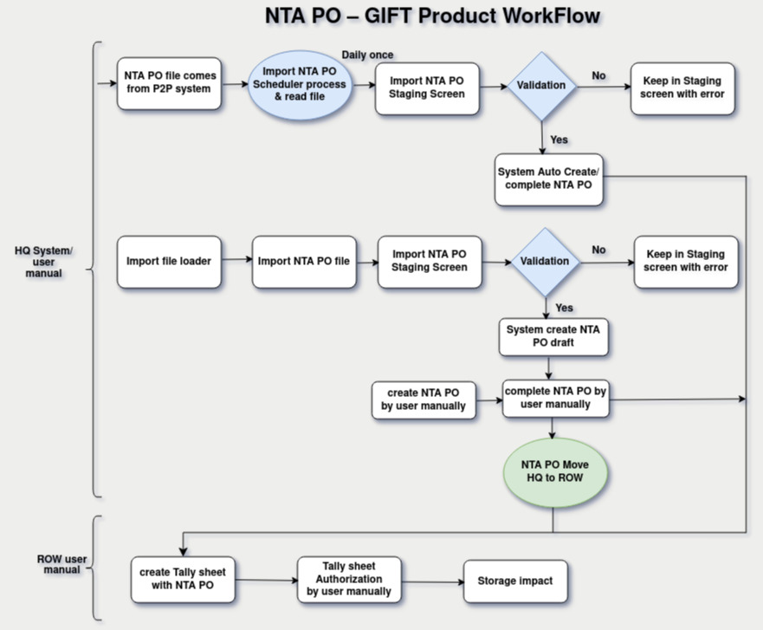

**Business Rules :**

* 3 Way of create NTA PO (Scheduler, Import NTA PO & Manual create NTA PO)
* Scheduler process NTA PO file comes from P2P system the files are located in a specific path (/home/Oracle/P2P/P2C)
* Import NTA PO scheduler process daily once & read the file
* After scheduler process successfully completed, NTA PO data inserted into a temporary table.(I_Order)
* Then validate and load the data is active Bpartner, product, qty, price & campagin
* the validation process has succeeded, it insert records in Main table-(_C_Order) user Process with completed NTA PO or they are kept in the temp table, and an appropriate error message is provided.
* Another way of NTA PO create process for import NTA PO
* Import NTA PO user process used for file loader
* xlsx file format only allowed to used Import NTA PO file used for file loader
* After user process successfully completed in file loader , NTA PO data inserted into a temporary table.(I_Order)
* Then validate and load the data is active Bpartner, product, qty, price & campagin
* the validation process has succeeded, it insert records in Main table-(_C_Order) user Process with draft status NTA PO or they are kept in the temp table, and an appropriate error message is provided.
* After complete the NTA PO manual by user in NTA PO screen
* Another way of NTA PO create process for manual NTA PO
* create NTA PO transaction manual by user in NTA PO screen & complete the transactions
* once completed NTA PO transactions move to regions user create Tally sheet with NTA PO
* once created Tally sheet Transaction by user after complete the Transactions in Tally sheet authorizations screen
* After completed the Tally sheet Transactions storage had impact